Lab 2: Creating advertisement using photoshop

Photoshop is a powerful tool for creating advertisements due to its extensive array of features for photo editing, graphic design, and layout customization. By following these steps, you can create an eye-catching and professional advertisement suitable for both digital and print media.

Procedure:

Step 1: Open Photoshop

Create new by selecting File->New or Ctrl + N.

Create desire dimension for the advertisement file.

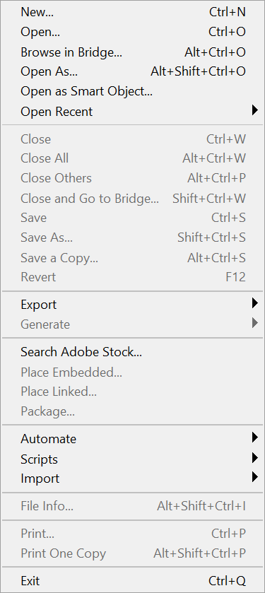 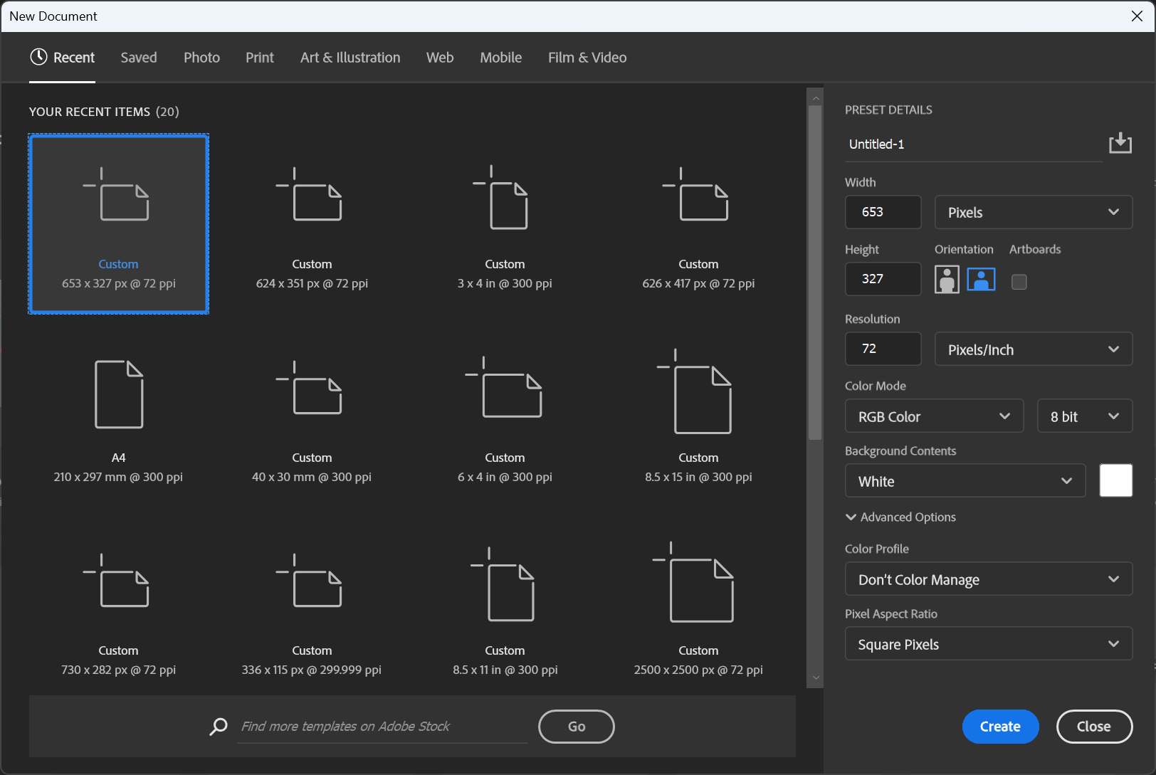

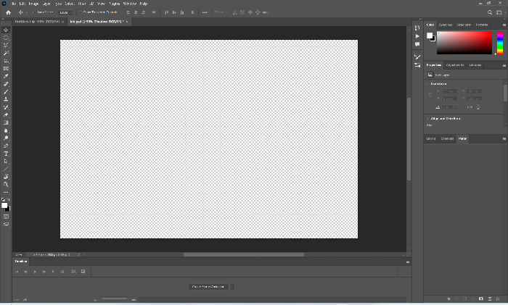  
Now you will have page something like this.

Step 2: Insert the subject and adjust according to your requirement.

Ctrl + o to open new file containing subject and drag it to your main page.

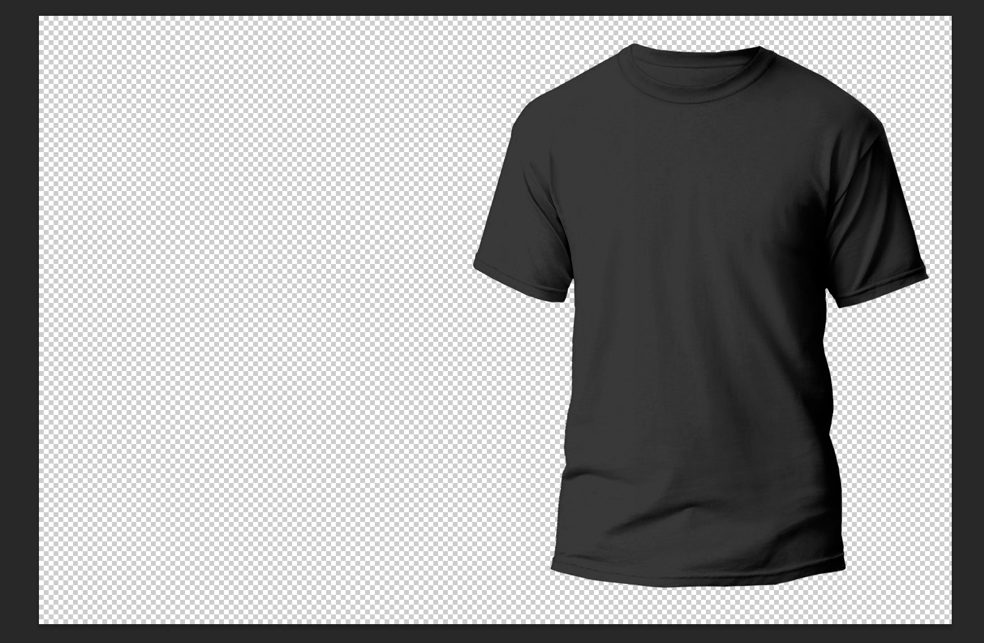 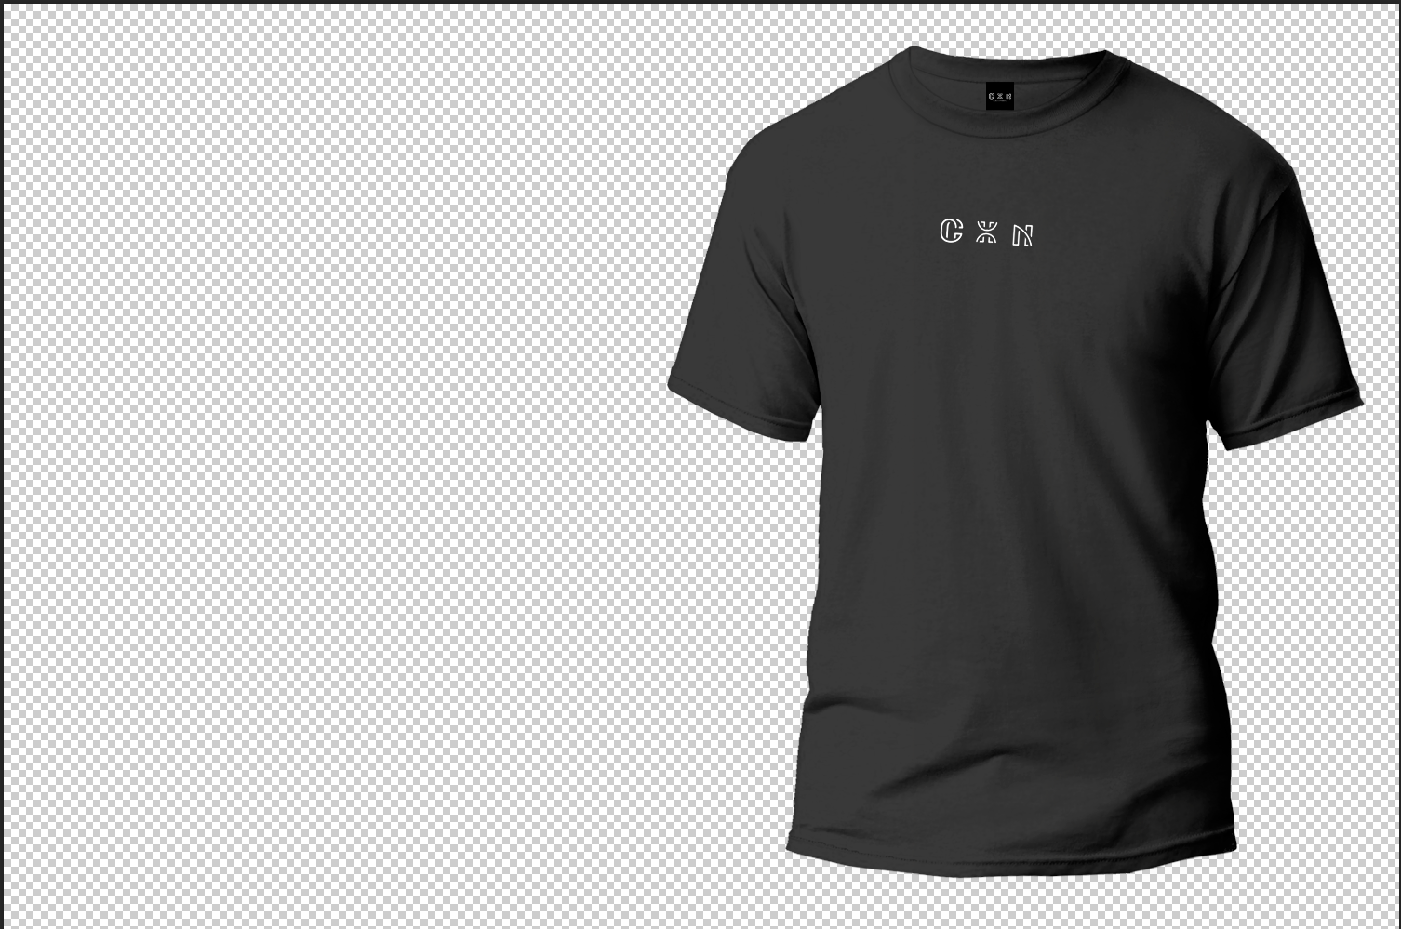

After adding detail to subject.

Step 3: add background and lighting

Create curve for lighting and shadow

Background is as same as dragging subject.

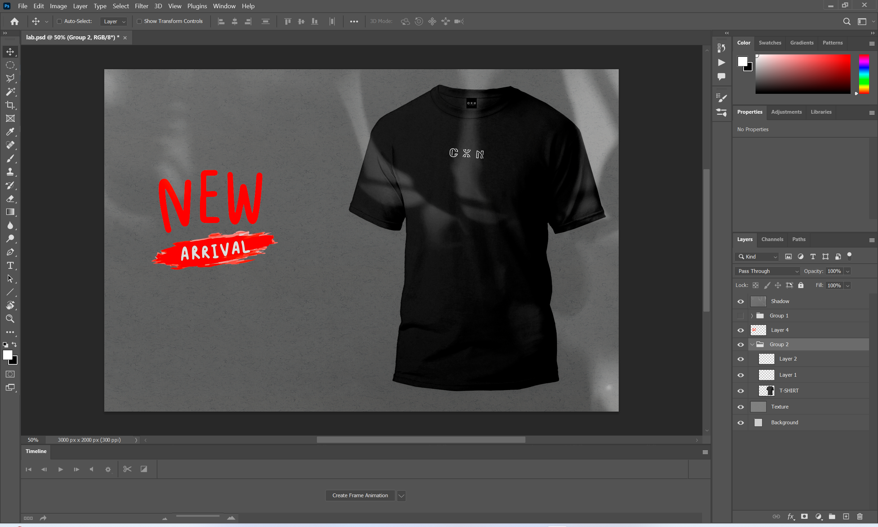

Final Output:

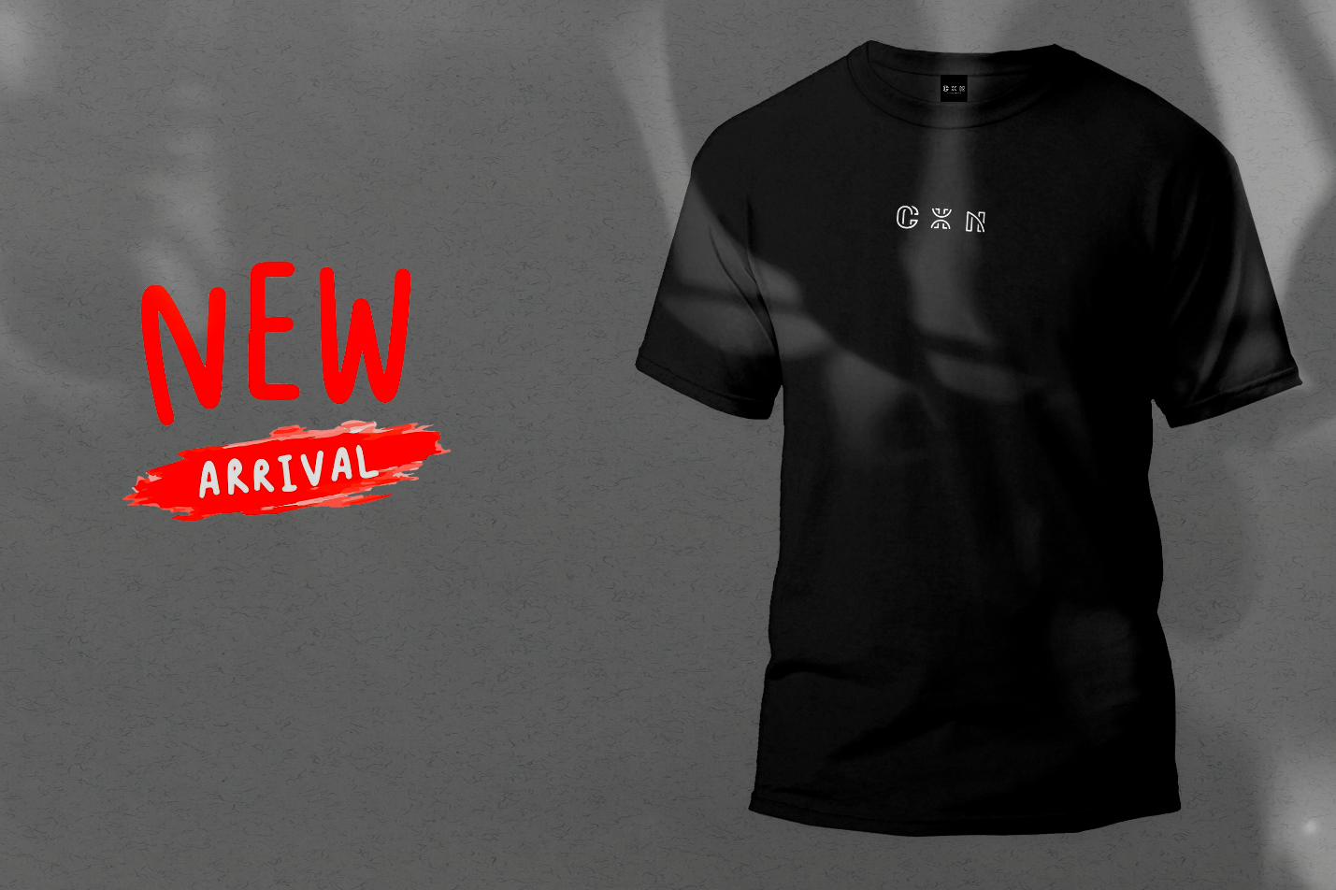

Conclusion:

Creating an advertisement in Photoshop involves setting up your document, importing and arranging images, adding text and graphic elements, applying effects, and organizing layers. By carefully designing and adjusting each component, you can produce a professional and compelling advertisement that effectively communicates your message and attracts your target audience. Photoshop’s comprehensive tools enable you to craft high-quality ads suitable for various platforms and purposes, ensuring your promotional material stands out.